SCAFFOLDING IN CLIL

Teacher: Enrico Santini

Dublin
February-March 2017


To start: challenges facing CLIL teachers

- The relationship between language and cognition is complex, but effective learning involves cognitive challenge.

- In CLIL settings it is essential to ensure that the language does not get in the way of understanding whilst at the same time it can itself be cognitively demanding.

- The greatest challenge for CLIL teachers is to develop materials and tasks which are linguistically accessible whilst being cognitively demanding.



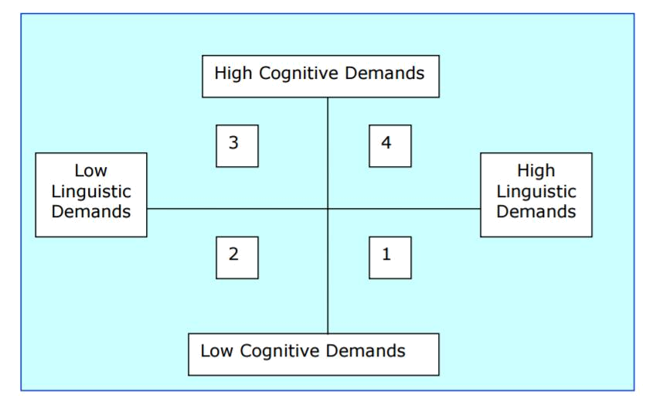
CLIL materials

“Quality learning materials do more than just communicate information. They promote critical and creative thought, discussion and learner autonomy.”

(Mehisto)
What (content) and Who (the learners)

- When selecting materials, it is necessary to evaluate them first from the point of view of the content and age appropriacy. It is necessary to make sure that the materials cover the content which is included in the curriculum, and have been designed for the same age group.

- After a material has been chosen, the teacher needs to decide about its purpose, clarity, demands it puts on the background knowledge of the students, and language difficulty.

- And then the teacher could decide how to support the learners in dealing with this material. Let’s look at some ways to do that through

Scaffolding



As with a lot of things the starting point should be a consideration of who your students are

“The biggest mistake in teaching is to treat all children as if they were variants of the same individual and thus to feel justified in teaching them all the same subjects in the same way”
(H. Gardner)
How can we provide scaffolding?

- Create interest - activate prior knowledge
- Break tasks into smaller chunks/steps
- Provide support to scaffold input and output - before tasks - pre-teach language – vocabulary
- use visuals, realia to introduce concepts demonstrate, model tasks

- during tasks: add in word banks, glossaries, substitution tables, writing frames

- use models for production after tasks, provide constructive feedback



Activities to help learners process language
Visual organisers

provide scaffolding for many types of input, including supporting reading and listening texts.
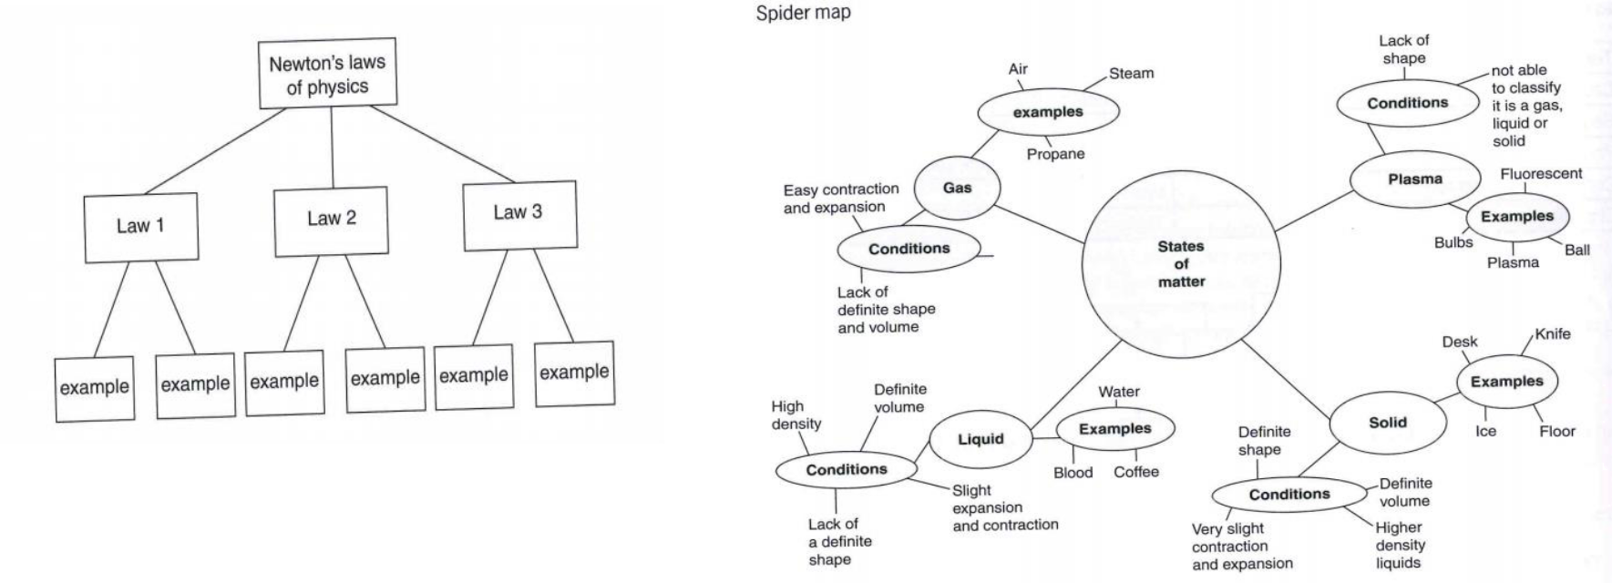

Reading materials can be adapted to include support

- Headings inserted

- Use of different fonts, colours, boxed or underlined etc to highlight important information.

- Definitions or explanations added

- Diagrams added

- Visuals included

- Glossaries included

- Visual organisers included to highlight important information
Speaking activities can be scaffolded with

- Pre teaching concepts using visuals, realia etc

- Activating prior knowledge – brainstorming – completing mindmaps / KWL tables

- Using a lead in to create interest

- Modelling activities

- Giving ample preparation time before the tasks

- Encouraging the use of speaking frames
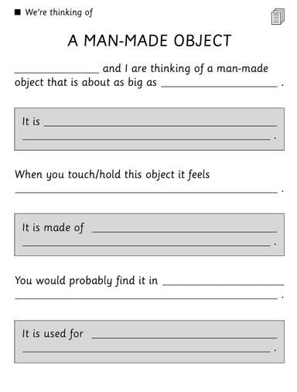
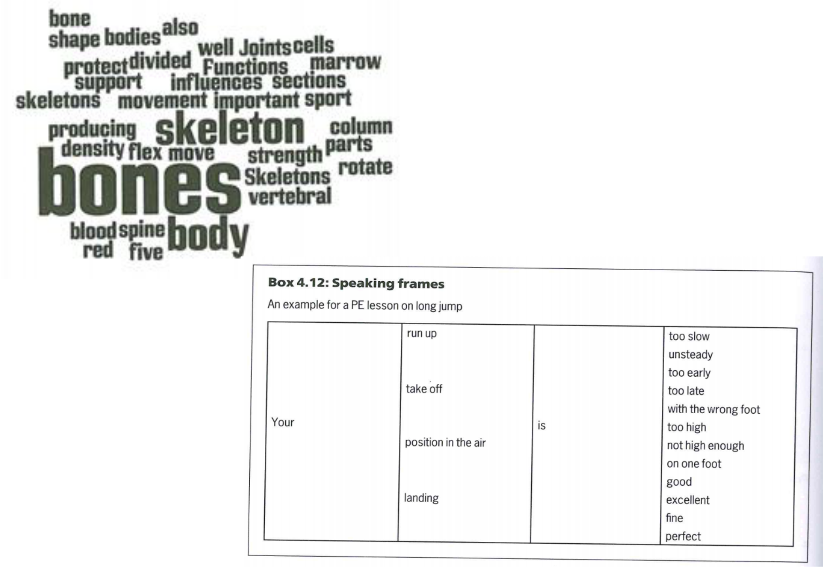
Speaking frames
Writing tasks can be scaffolded using

- Pre teach language

- Brainstorm ideas – mindmaps

- Model texts to examine and use for guidance

- Encouraging process writing – planning, drafting, editing

- Encouraging the use of writing frames – sentence starters, useful phrases etc
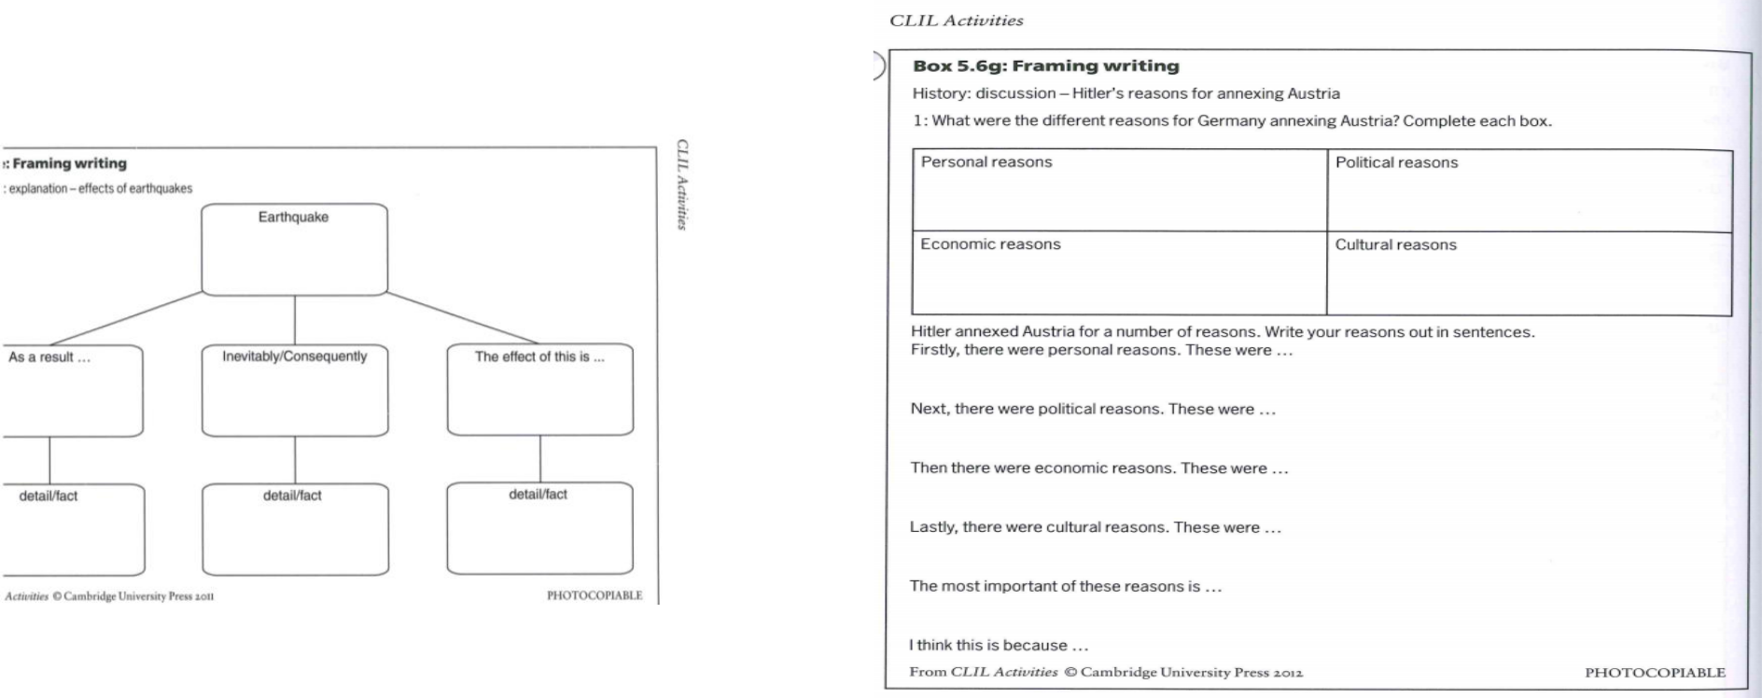
Writing frame
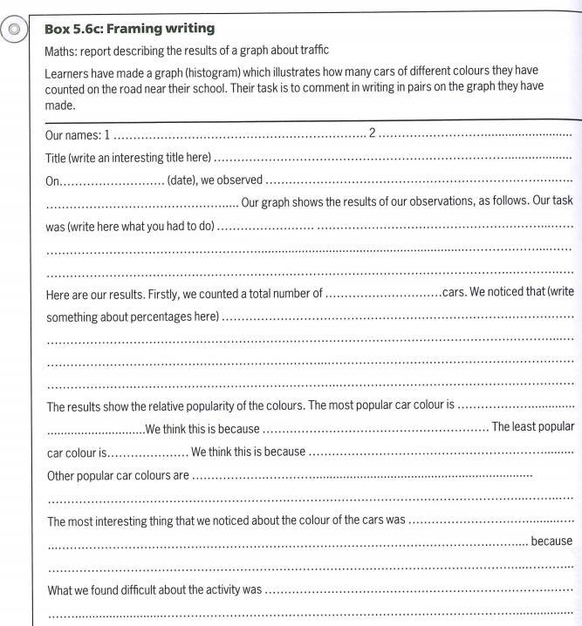

What can scaffolding do?

- Engage / motivate the learners

- Provide a clear direction

- Keep learners on task

- Guide learners to useful resources

- Reduce surprise / uncertainty / disappointment / frustration

- Deliver efficiency - help learners to work more efficiently / effectively

- Make learning more individualised

“What learners can do today with support, they can do alone tomorrow”
(Vygotsky)



